22-10-2021

ABHINAV RANJAN

RA1911003010003

CSE A1 SECTION

SRMIST , KTR

CN LAB EXP 13 - VPN

Main page :

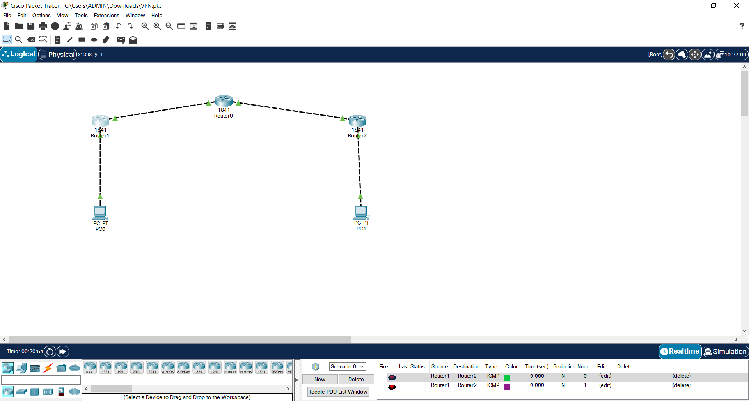

Router 2 pinging router 1 :

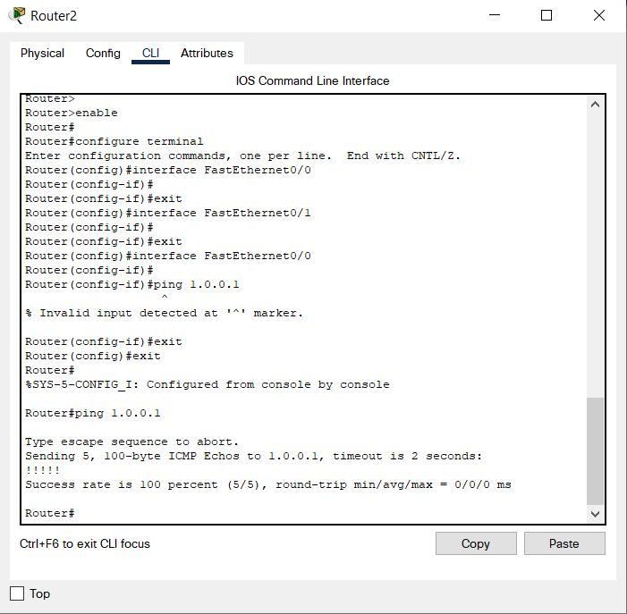

Router 1 pinging router 2 :

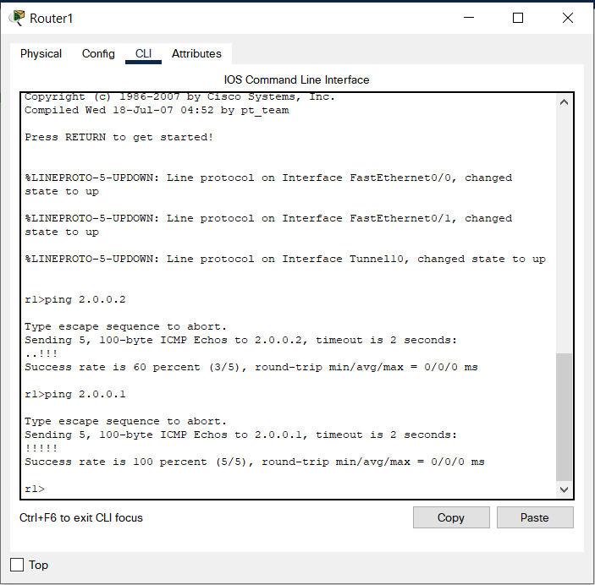

PC0 pinging PC1

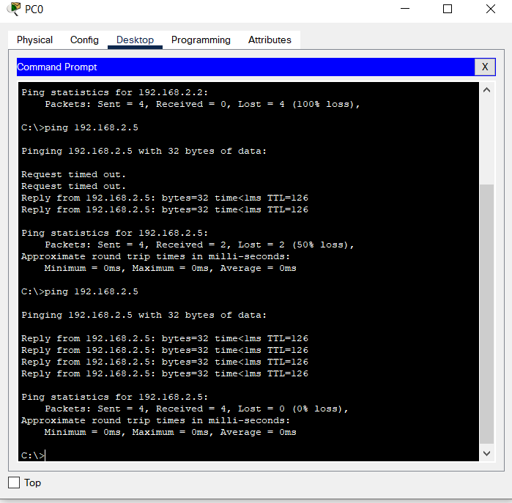

PC1 pinging PC0

